Tamra: 3 phase recitifer, no smoother: <http://hackedgadgets.com/wp-content/uploads/2010/10/3-phase-bridge-rectifier.png>

<https://en.wikipedia.org/wiki/Rectifier#Three-phase_bridge_rectifier>

Lipo Charger Rectifier circuit (we would need to make it 3 phase though):

(from <http://www.wattflyer.com/forums/showthread.php?t=20575>)

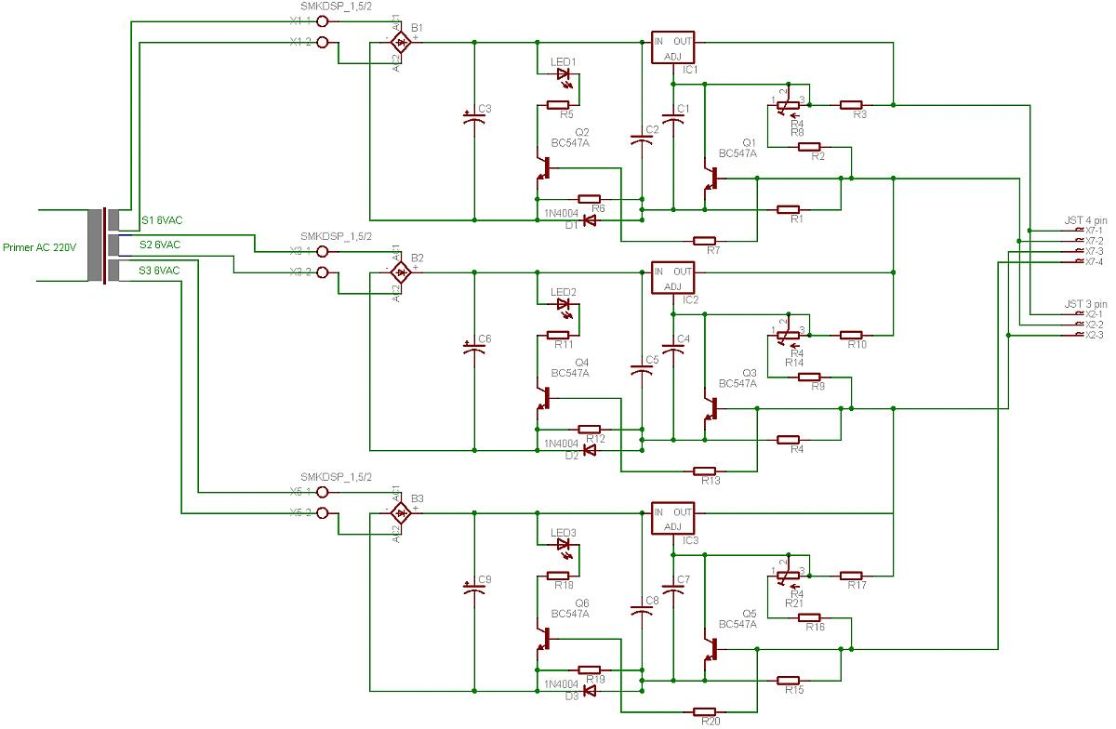

Raiyan 9/27 update: 3 phase rectifiers signals need a 3 phase - 6 pulse rectifier: <http://www.technik-emden.de/~elmalab/projekte/ws9899/pe_html/ch05s1/ch05s1p1.htm> 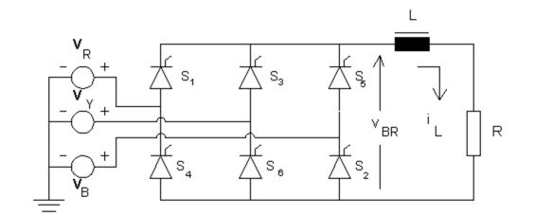

Best rectifiers use thyristors - we may be able to use diodes likely depending on our current spec. Website above gives pretty good intro to diode or thyristor use in 6 pulse rectifier (NOTE: thyristors are also known as SCR, silicon controlled rectifier).

(Ignore these ramblings, just me trying to learn thyristors. We might not end up using rectifier with these) Using thyristors (<http://www.explainthatstuff.com/how-thyristors-work.html> - great animation towards the bottom), semiconductor devices that act like combination of transistor and diode - current can be sent to the thyrister gate so that they only conduct for certain phase angles of input sine waves. Thyristors should be used over transistors because they can handle high current and do not amplify. Thyristor video narrated by Stephen Hawking: <https://www.youtube.com/watch?v=v58KiktJLyE>

We could try to design one of these. Or, we could buy one. Even Walmart sells them <https://www.walmart.com/ip/80Amp-1000Volts-3-Phase-Diode-Bridge-Rectifier-SQL80A/47822653?wmlspartner=wlpa&selectedSellerId=571&adid=22222222227035268547&wl0=&wl1=g&wl2=c&wl3=75766896874&wl4=pla-176020087714&wl5=9060147&wl6=&wl7=&wl8=&wl9=pla&wl10=111838760&wl11=online&wl12=47822653&wl13=&veh=sem>

Amazon <https://www.amazon.com/3-Phase-Three-Phase-Bridge-Rectifier/dp/B004FGIVN8>

We need to find out what sort of current we’re expecting to put through here before we select a rectifier. Also need to know what kind of voltage inputs the battery wants.

Raiyan 10/5 Update: Prof Brooke gave several bundles of 8AWG wires and 18 high current schottky diodes - enough for 3 rectifier circuits. Need to determine whether these wires and diodes can handle the current, whatever it is..

Importantly, Brooke seems confident that just connecting the ESC and rectifier in parallel will work: as long as the ESC is not receiving any control signals, only a small amount of current should go backwards through the ESC MOSFETs. Most of the current should go back through the rectifier into the battery.

Outrunner datasheet lists max current as 150A. 8awg wire shouldn’t transmit more than 80A. Diodes can conduct 240A-1500A - lol. Will these wires work or should we go fatter/parallel connections? Interesting to note that the battery and ESC cables look like they’re 8 or even 10awg. This may mean that 8awg is fine.

Need to figure out connections - what are the connectors on the LiPo and ESC called? Need to get more of these and split them into Y’s to avoid splicing the battery or ESC cables.

Need to figure out proper way to solder high current splices: according to several sources, you can just solder them normally just with more care - probably lineman’s splice.

First pass at a schematic:

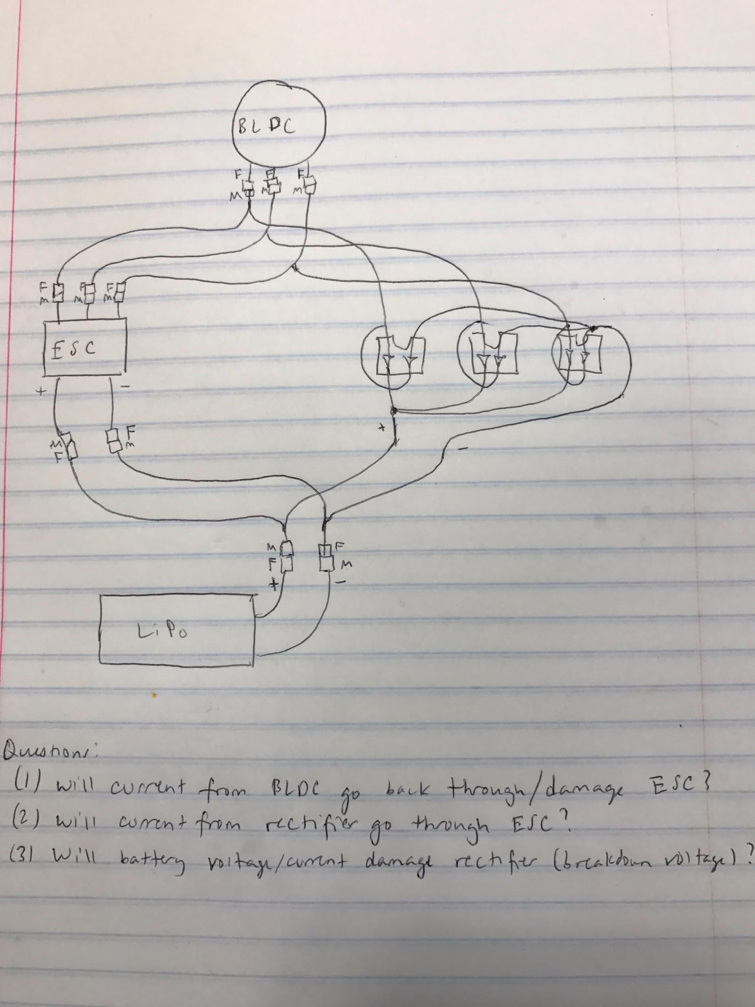

Raiyan/Edward 10/7:

Turns out that all ESCs (most likely including ours) do allow for some degree of regenerative braking, but a lot of the energy is given off by heat http://www.rc-monster.com/forum/showthread.php?t=18978. Regenerative braking works through sharp back EMF spikes. Trying to use these for continuous power regen would probably melt the ESC. We might not want to try the topology above like Brooke mentioned, though he did seem confident that the FETs would be fine. Finding a spec sheet for the MOSFETs might help in this decisions. These seem to be hard to find. Worst case, cut the packaging off the ESC and look for a P/N on the MOSFETs.

Plan 0: If we believe Dr. Brooke try the topology above. Need to research the FETs for this.

Plan 1: try the topology above with a relay in series with the battery

Plan 2: get an ESC meant for backwards commutation (regenerative braking ESC)

Problem with plan 1: every time we switch we will be powering off the ESC and need to redo the initiation sequence. If the frequency of switching is high, will need to find another way.

Just occurred to me that an ever bigger question than figuring out rectifier circuitry is figuring out what will happen when current is flowing into the battery. LiPo + uncontrolled current = not fun (<https://www.youtube.com/watch?v=gz3hCqjk4yc> video explaining why, featuring Russian rednecks).

Found a great intro to LiPos. <http://www.rchelicopterfun.com/rc-lipo-batteries.html>. Seems like it should be okay even if not perfectly balance charged. Battery performance will just deteriorate much faster.

Questions for Dr. Brooke:

* What sort of load will be needed on the battery, or what frequency of switching between starting motor and generator

Things to get: Decided to spec things out to ~60A (because battery max charge is 50A)

Relay: <http://www.newark.com/durakool/dg85b-8011-96-1006-m1/automotive-relay-spdt-6vdc-60a/dp/30M9197>

If relay does not have any current amplification on input, need to buy amplifier. Might need to buy diode for inductive spike protection.

Current sensor:

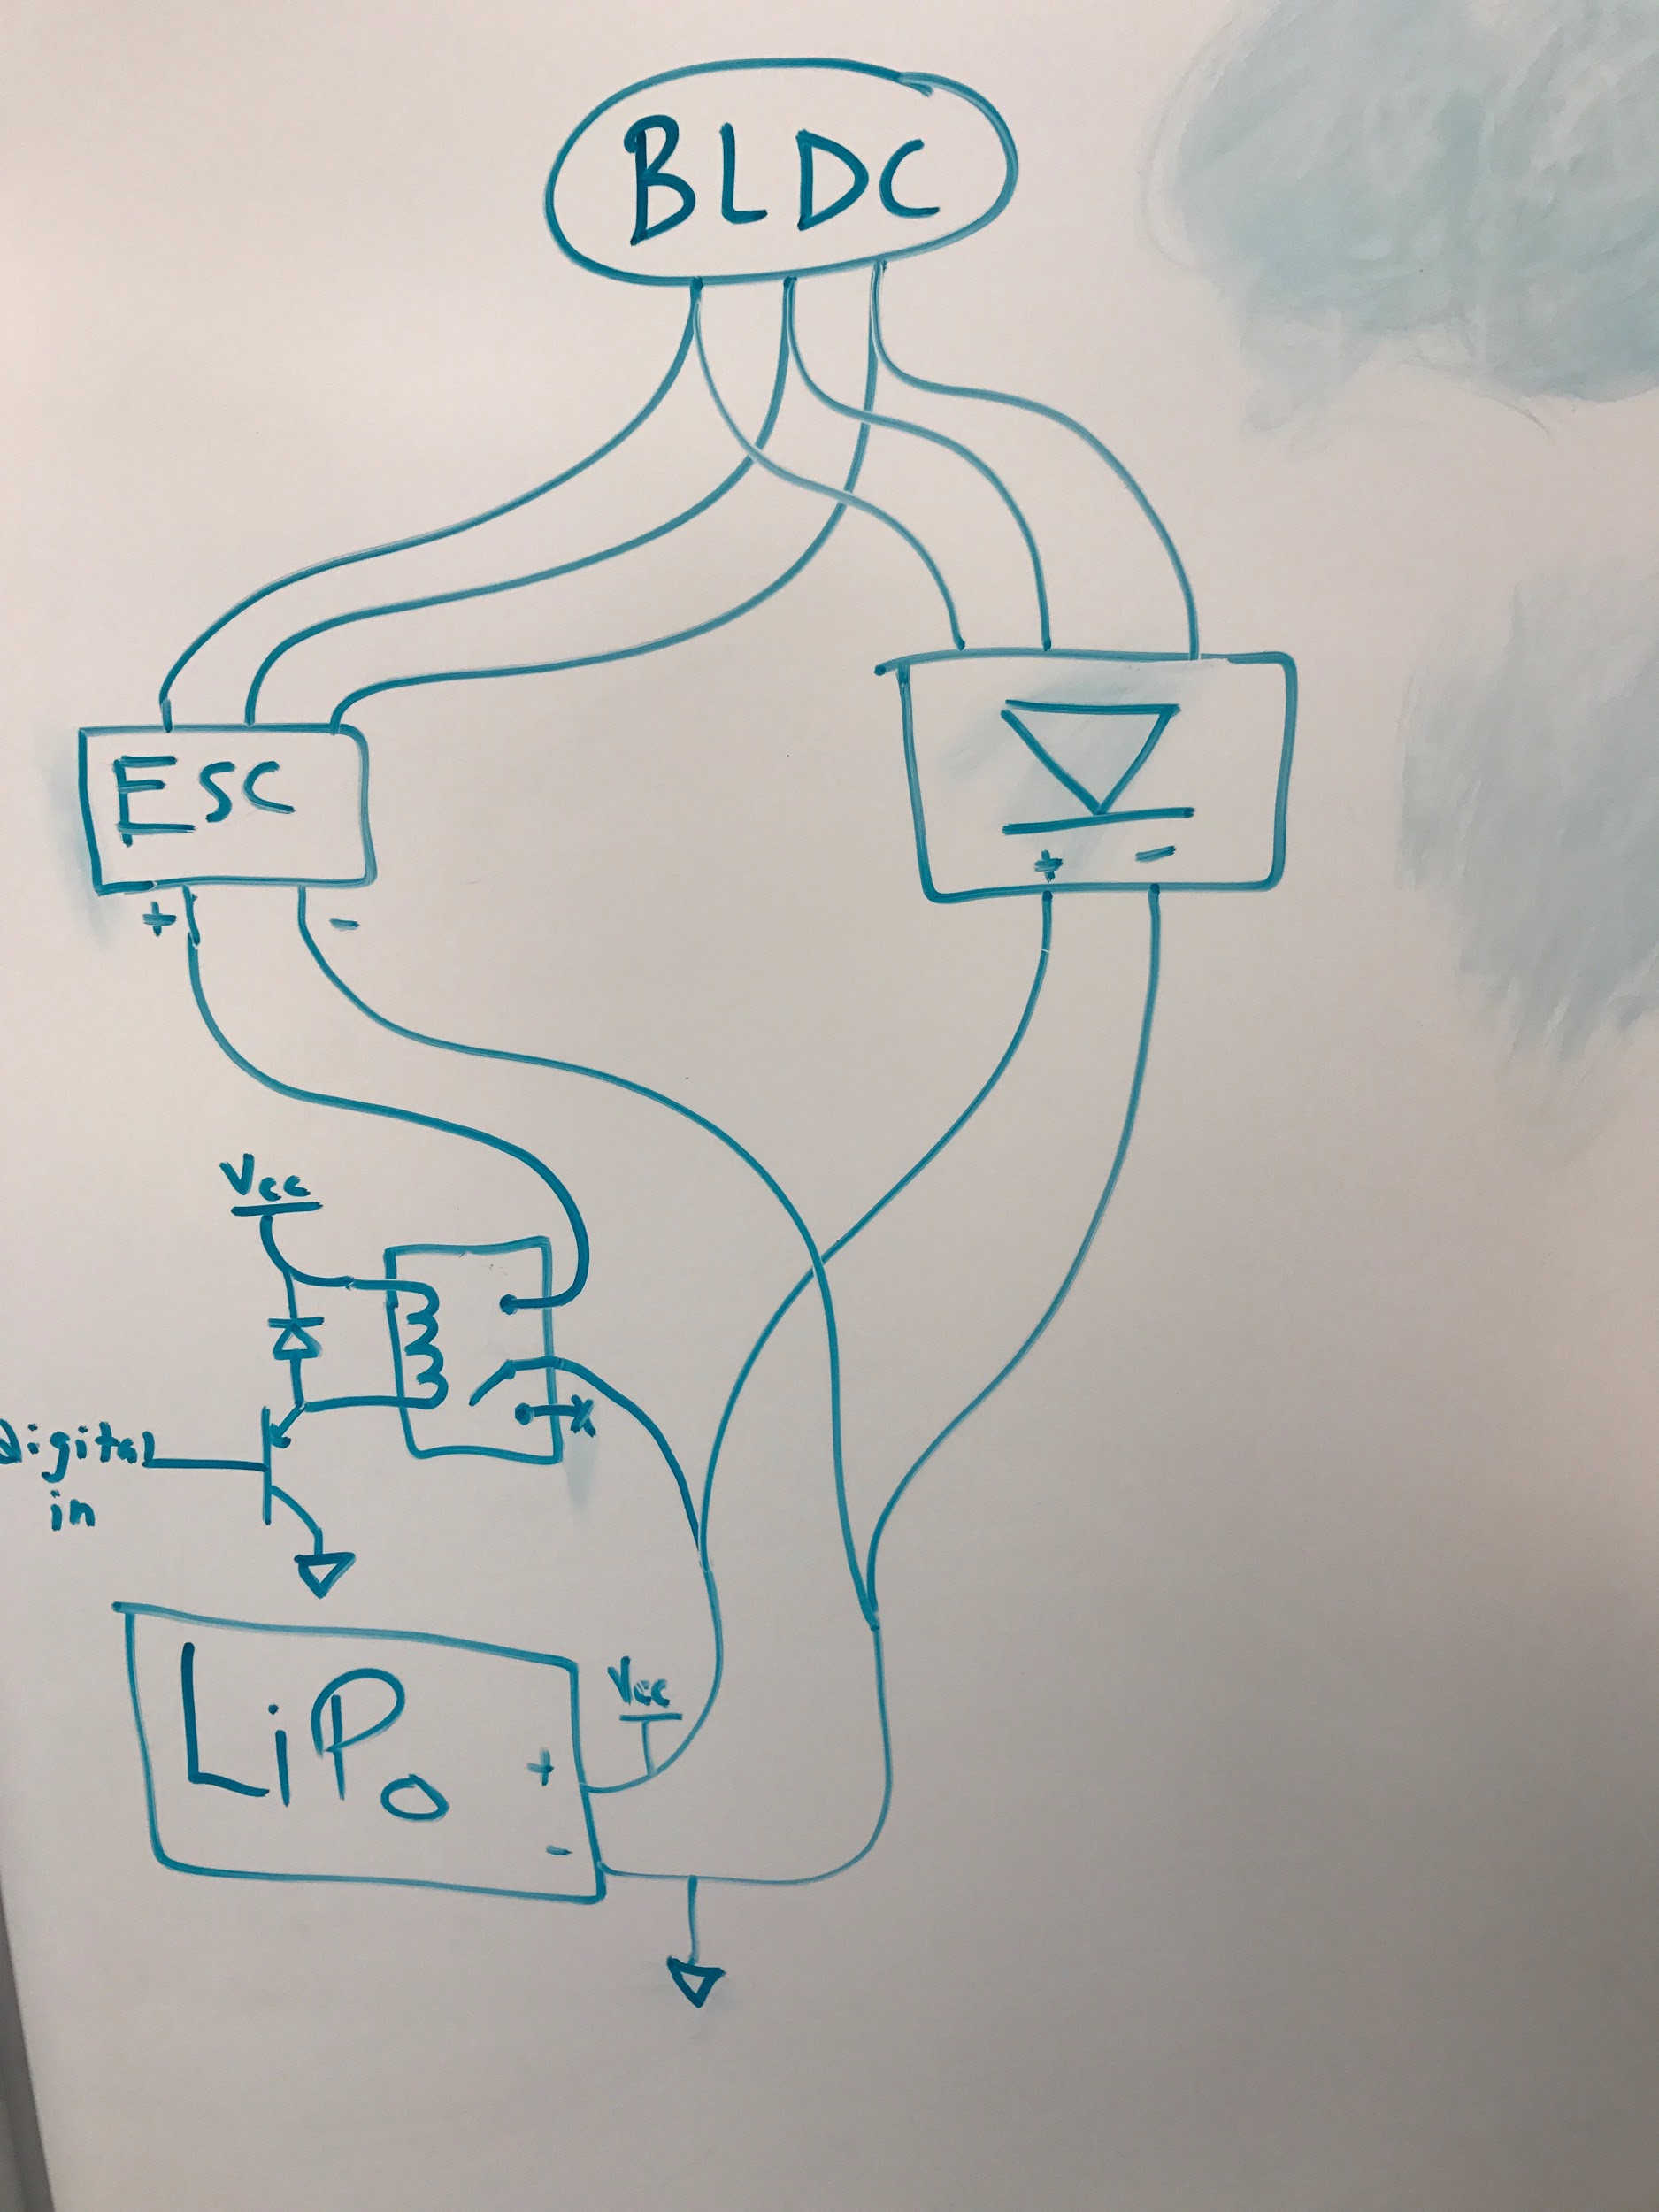

Raiyan 10/13

Max Battery charging current: 10C * 5000mAH = 50A (10C is a suggestion from manual, “some” batteries can go up to 15C)

Parts to order:

|  |  |  |  |
| --- | --- | --- | --- |
| Part | Units | Link | Notes |
| 3.5mm bullet connectors | 2 | https://www.amazon.com/Generic-3-5mm-Bullet-Connector-Battery/dp/B00EZKW1T4 | Not sure if we have these already - I found some in the lab and measured them to only be 3mm |
| Relay 80A | 1 | <https://www.amazon.com/gp/product/B001PNMBE4/ref=pd_cp_107_1?ie=UTF8&psc=1&refRID=JS7BEKN3FS8VDJBWM6Y6>  Specs: http://www.gamainc.com/site/files/941/130307/513823/762359/Y161C12D_WEBSITE.pdf |  |
| Relay 50A | 1 | https://www.amazon.com/HELLA-007793041-SPST-Relay-Bracket/dp/B0068M2LYC |  |
| V Regulator for 12V | 2 | https://www.pololu.com/product/2834 | Output 12V, 1A |
| Diode |  |  | Might have these somewhere? Ask brooke |
| Current amplifier (transistor, mosfet, etc.) |  |  | Might have these somewhere? Ask brooke |
| Current sensor | 2 | https://www.fpvheadquarters.com/accessories/power-accessories/current-sensors/tbs-current-sensor-100a.html | Can measure up to 100A, input voltage 3.7-42V, Linear Output |

Raiyan/Edward 10/14

Possible that we should use a solid state relay instead: control current for these can be <10mA, won’t need a bias diode, etc. Slightly more expensive. Seems like most of these are rated for AC output only, why? SSR can only do AC **or** DC.